Kerr County A&M Club
Benefit Golf Tournament
October 4, 2021
12:00 p. m.

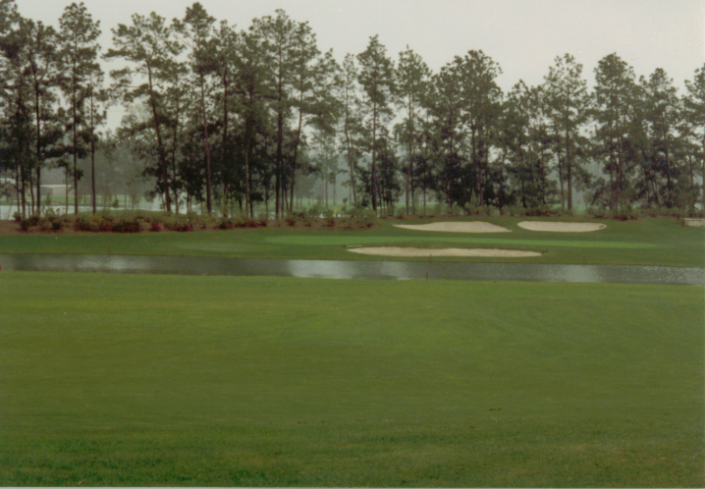

tx.ag/2021KerrGolf

Riverhill Country Club
100 Riverhill Club Ln.
Kerrville, Texas 78028

The Kerr County A&M Club tournament will be played at Riverhill Country Club on October 4, 2021. The proceeds provide scholarship assistance to Kerr Co. High School students accepted to Texas A&M University.
This 4-Man Scramble is a Shotgun Start and will begin at 12:00 p.m. The $125 Individual Entry Fee, or $500 per team will include Golf, Cart, Range Balls, Closest to-the-Hole, Long Drive, and Hamburger Dinner. Mulligans limited to (1) per player are available for $10 each. There will also be a $10 Putting Contest and Silent Auction. Prizes will be awarded for 1st $500 2nd, $400 and 3rd $300 Low Gross, Closest-to the -Hole 2X $50 and Long Drive $50. Putting Contest $80.

Registration begins @ 10:00 a.m. Preregistration Deadline Sept. 13, 2021
(Walkups Welcome)

SPONSORSHIPS

Gold Sponsor $500 “Tournament Title” Sponsor

Silver Sponsor $250 Beverage Cart or Food Sponsor

Bronze Sponsor $225 Putting Green, Driving Range or Silent Auction

Maroon Sponsor $150 Closest-to-the-Hole or Long Drive Sign

White Sponsor $125 Hole Sponsorship with Sign
_______________________________________________________________
SPONSORS

Sponsor Name _____________________________ Phone ______________ __

Sponsorship Level __________________________________________________

Address __________________________________________________________

City __________________ State _______ Zip _____________

E-mail ____________________________________________________________
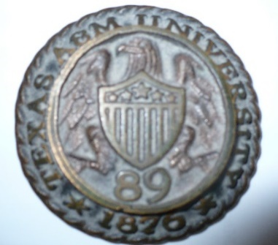

Individual Player $125

Individual _______________________ Phone ____________

Address ______________________________ Hdcp. Amount

City _____________ State _______ Zip ________ ______ $_________

Handicaps Appreciated __________________________________________________

Teams $125 per Team Player
Hdcp. $ Amount

A Player: ________________________________ _____ ________

B Player: ________________________________ _____ ________

C Player: ________________________________ _____ ________

D Player: ________________________________ _____ ________

Make all Checks Payable to: Questions Contact Chairman:

Kerr County A&M Club John M. Penaloza ’89
103 Live Oak Lane Mob: (830) 377-0034
Kerrville, Texas 78028 jpenaloza@windstream.net
Attn: John M. Penaloza ’89
or Vice Chairman
Jared Hunt ‘12
Mob: (830) 370-9268
hunt2651@aggienetwork.com

